**Daily Scrum or Standup Meeting**

Team name: ______TEAM 4___________________

Scrum Master: ______ Sterling Tolley_________

Date:___________10/30/19____________________

|  |  |  |  |
| --- | --- | --- | --- |
| **Team Member** | **What did you do since the last scrum?** | **What do you plan to do before the next scrum?** | **What obstacles do you have?** |
| Carter Figgins | Not much | Working a live items for listing and unit testing. | none |
| Brock Francom | Worked on integrating the ItemListView and itemView | Finish integration of the views, and get the pictures working | Lazyness. |
| Waseca Hodson | N/A | N/A | N/A |
| Sterling Tolley | Created library of functions for user verification and registration | Implement verification across all view, create registration view | none |
|  |  |  |  |

# Burndown

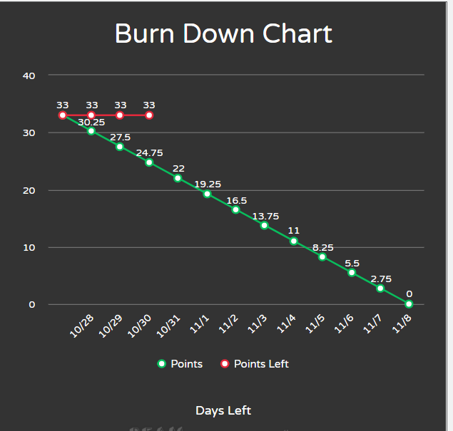

# Screenshot of you project board

